3-Tier Architecture using Azure Portal

1. What is 3-Tier Architecture
3-Tier Architecture means dividing an application into 3 simple parts:
1. Frontend – This is what the user sees (website or app)
2. Backend – This handles the logic or processing work
3. Database – This stores the data
2. Azure Services Used
  - Frontend - App Service
  - Backend - Virtual Machine (VM)
  - Database - SQL Database
3.Diagram: 3-Tier Architecture
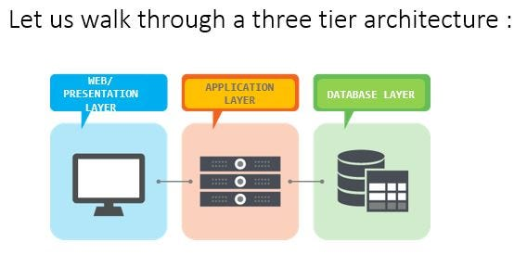
4.Tier Definitions
- Presentation Tier: This is the frontend. Users see this. Example: Nginx Web Server
- Logic Tier: This is the application logic. It connects frontend to backend. Example: Tomcat Server
- Data Tier: This is the database layer. It stores data. Example: MySQL

Azure Setup Steps.
👉 Login to https://portal.azure.com/#home

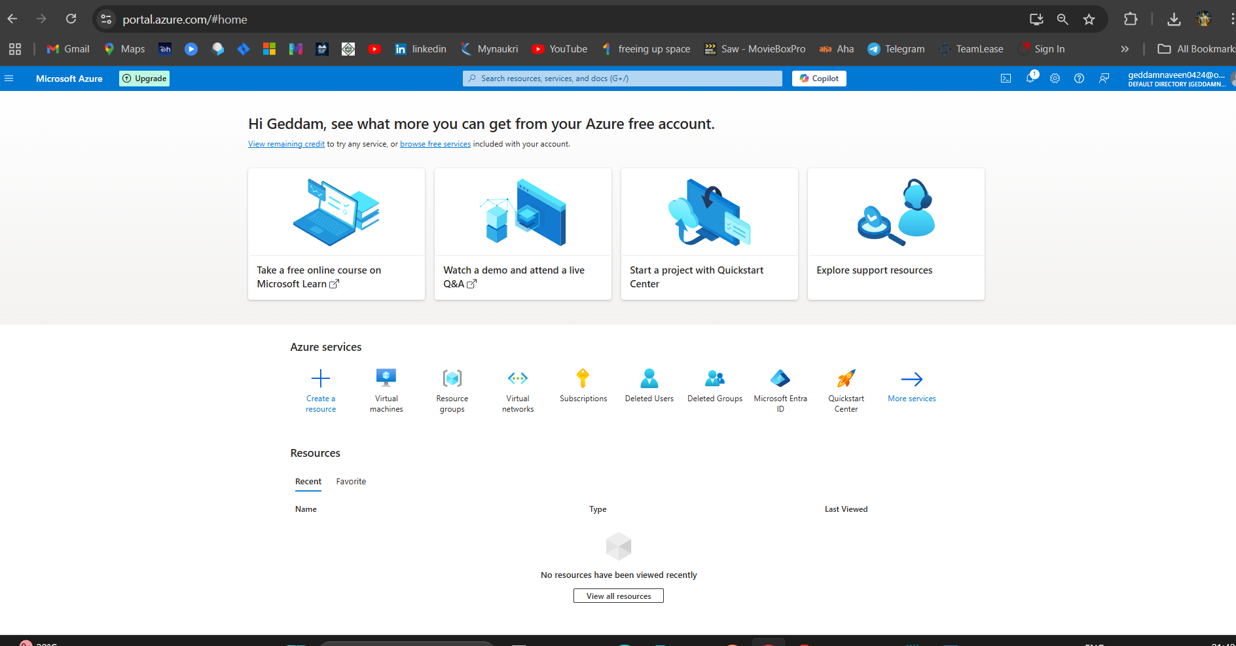

Step 1: Create Resource Group :
Resource Group is a logical container in Azure that holds related resources (like VMs, networks, storage) and allows you to manage them together as one unit.

1. Search 'Resource Groups'
2. Click 'Create'
3. Name it: GNK_3-tire
4. Choose Region
5. Click 'Review + Create' then 'Create'
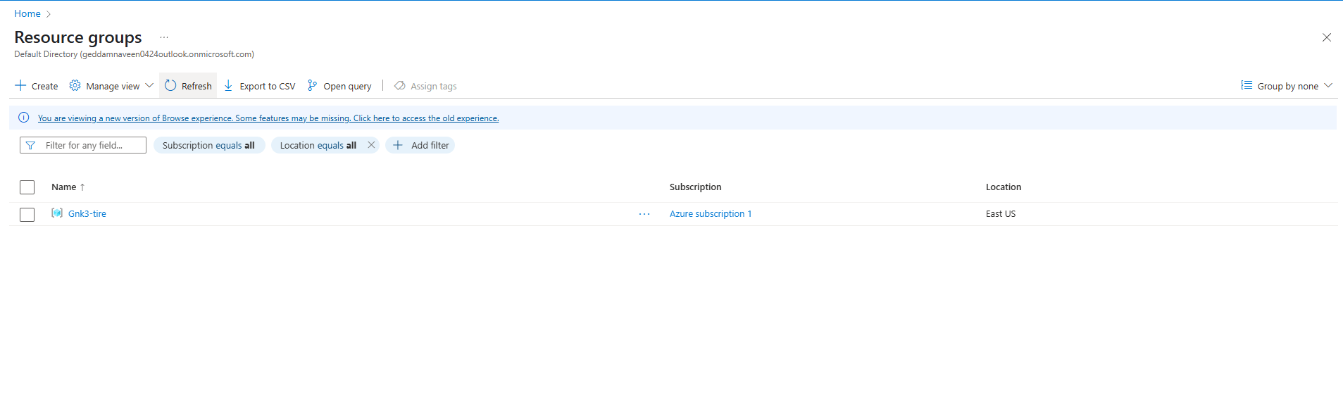
Step 2: Create virtual network :
Azure Virtual Network (VNet) is a private, isolated network in Azure cloud where we can host and securely connect virtual machines and other resources. It works like our own data center network in the cloud.

1. Search 'Virtual Network'
2. Click 'Create'
3. Name it: GNK_3-tire-Vnet
4. Choose IP address
Create a 3 Subnets Web subnet, App subnet, DB subnet
5. Click 'Review + Create' then 'Create'

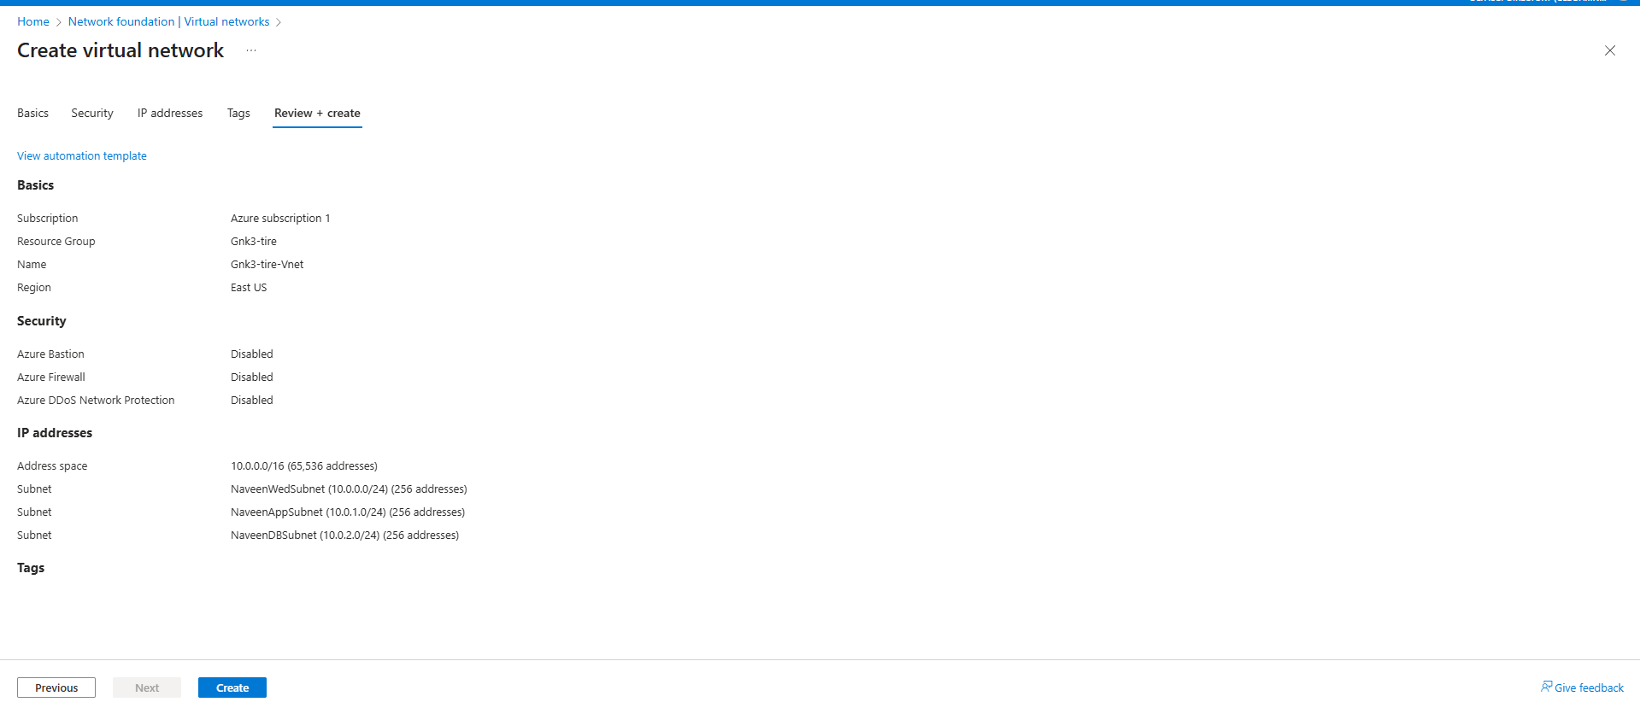

Step 2: Create Virtual machines
1. Search 'Virtual Machine'
2. Click 'Create'
3. Name it: For each subnet and each virtual machine, we can give names as per our choice
4. Create 3 subnet and 3 virtual machine
5. Click 'Review + Create' then 'Create'

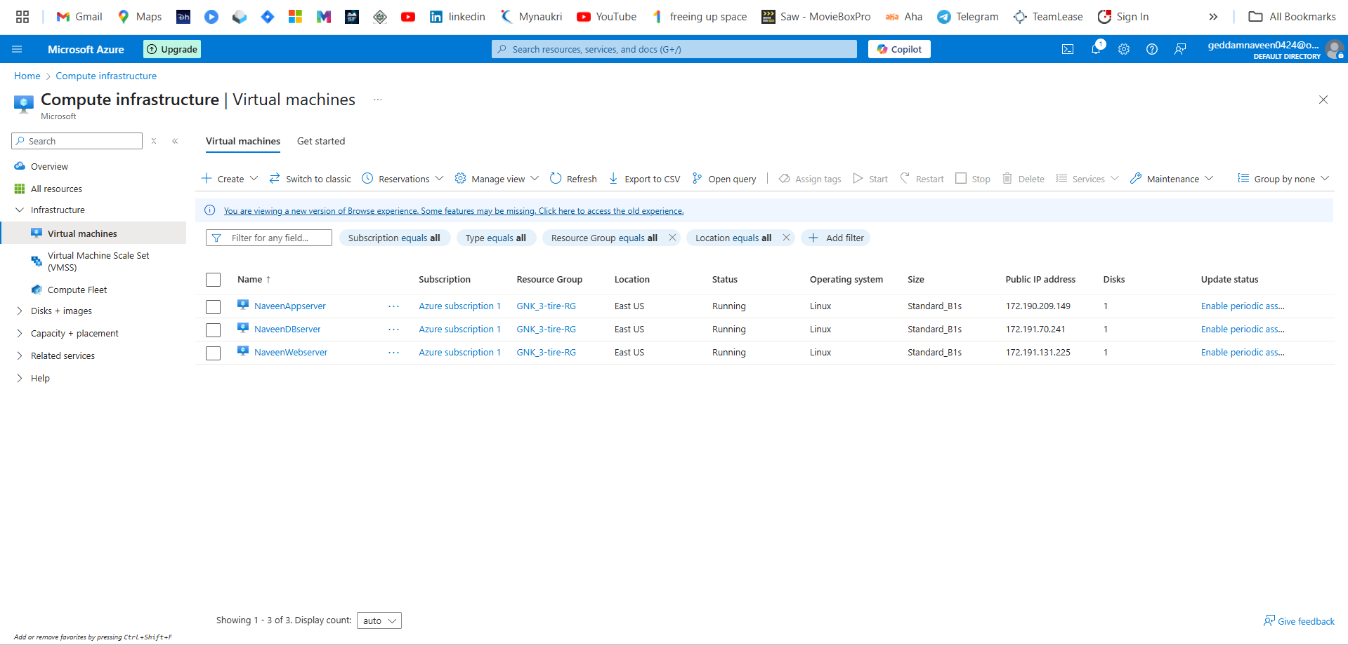

Meanwhile let me cent to the machine I using MobaXterm application and if you want use putty also

1. I using NaveenWebserver Virtual Machine this is my webserver name
2. open MobaXterm application
3. We check with Public IP 172.191.131.225 – this my Public IP
4. Open MobaXterm select the SSH and Specify userbame
IP Address : 172.191.131.225
Name : Azureadmin
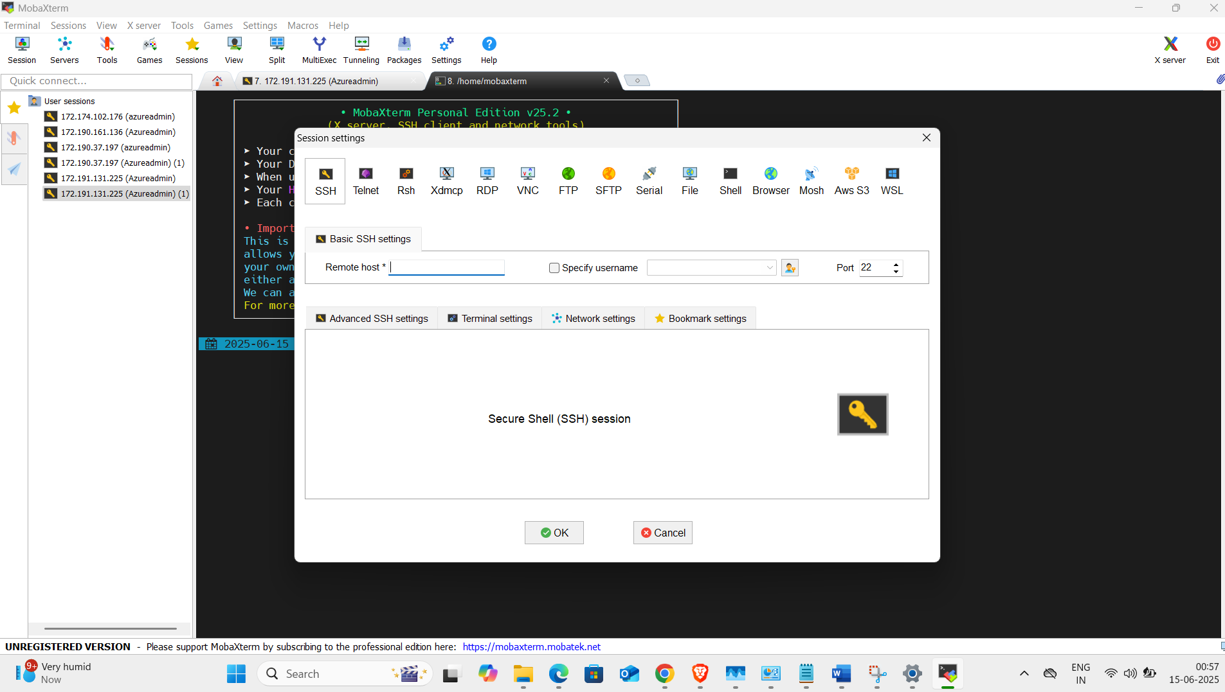
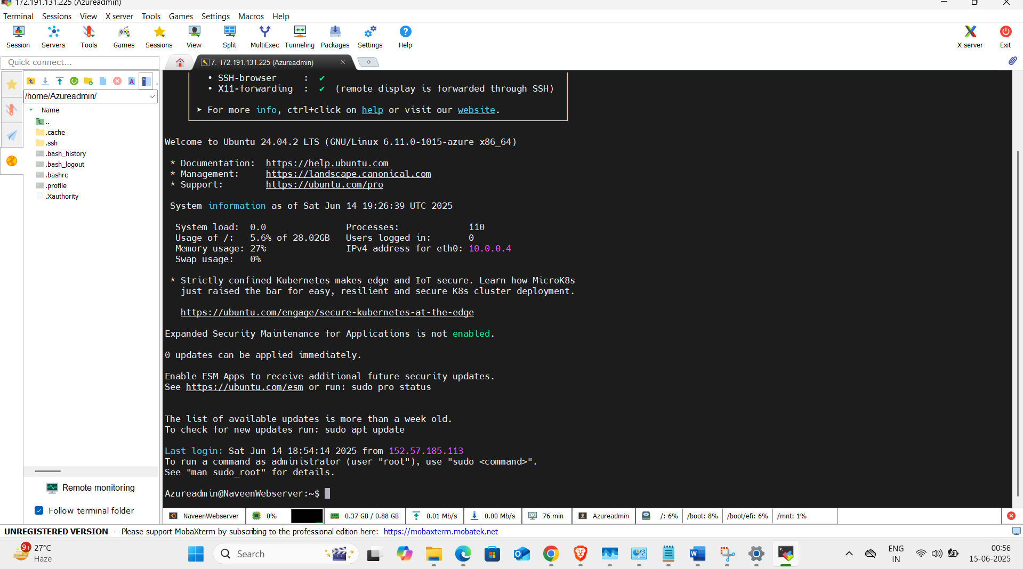
Now its contented.

- at the same time we login the user is normal user .
- If we login the normal use so we cannot run the anything like we do have any privileged run.
- 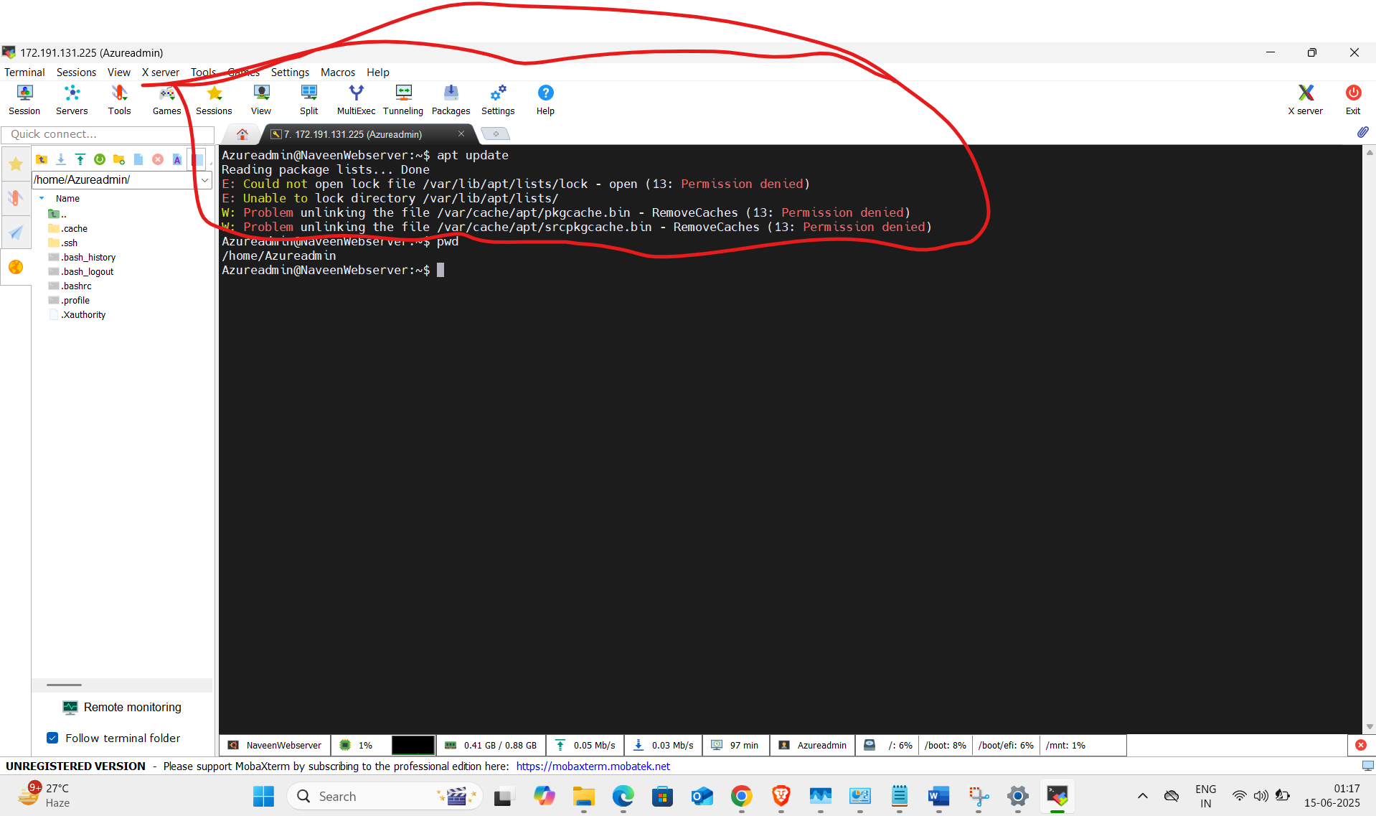
- Must we switch normal user to root user for the admin user.
- We used the pwd cmd, pwd its Print Working Directory, its showing present path . ex pls check below screenshot
- 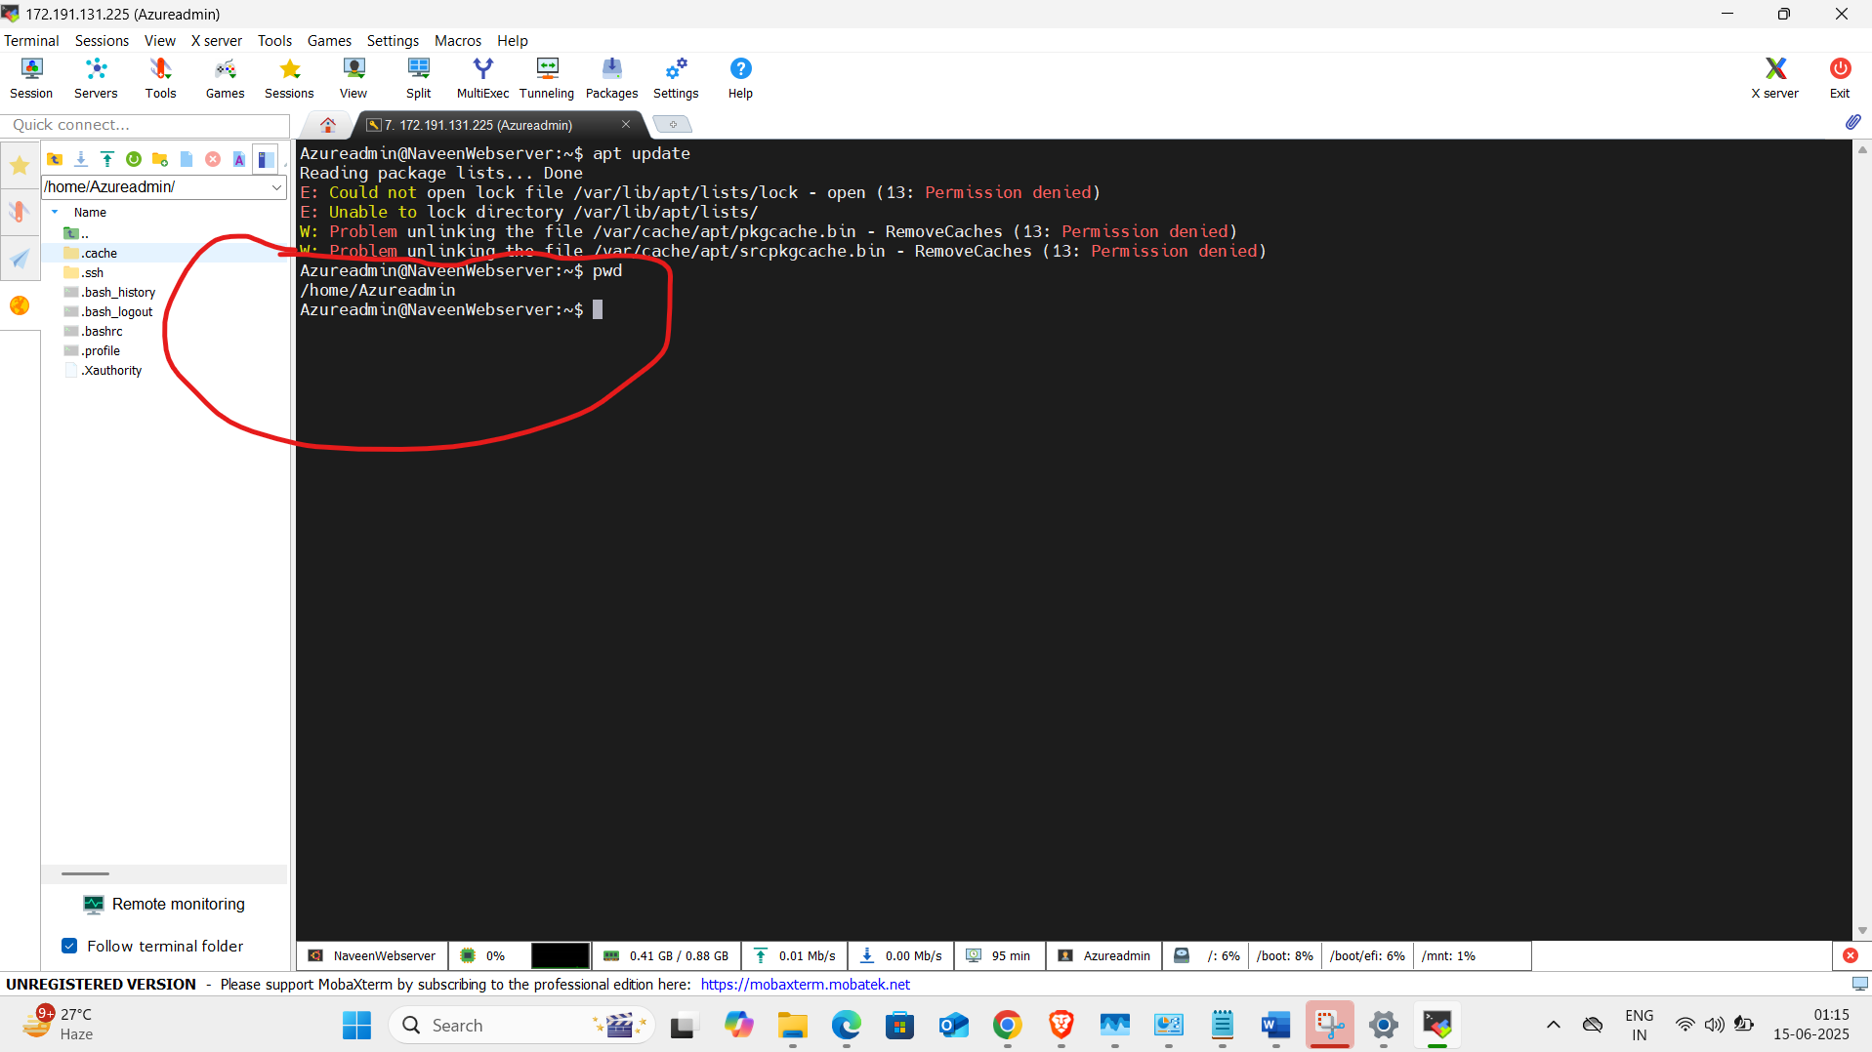
- When we enter the “sudo su” cmd still its showing home Path we block in root user so we exit the “sudo su” , find the below example screenshot
- 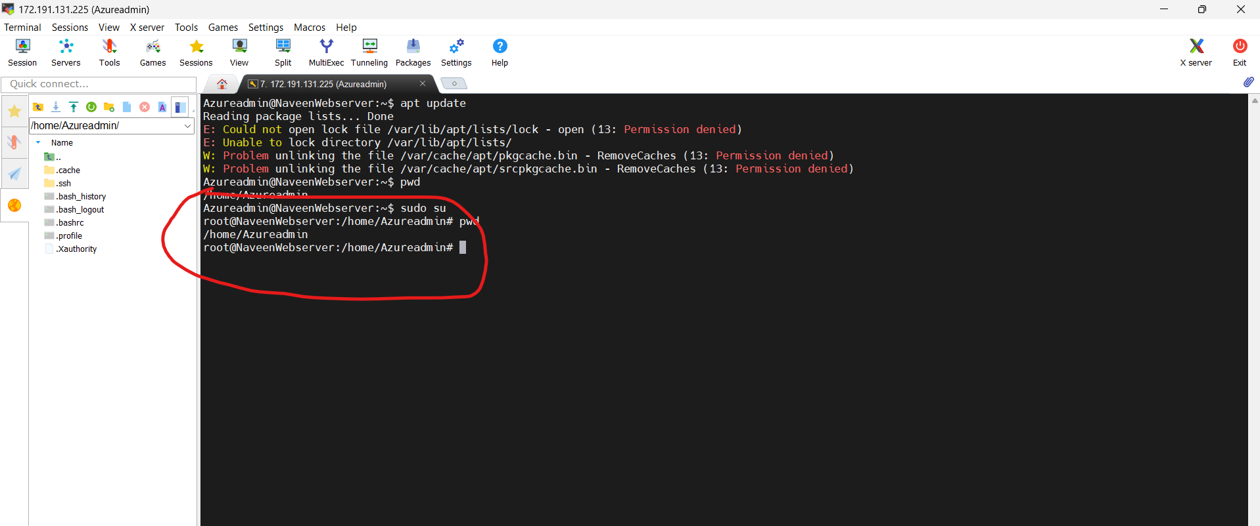
- 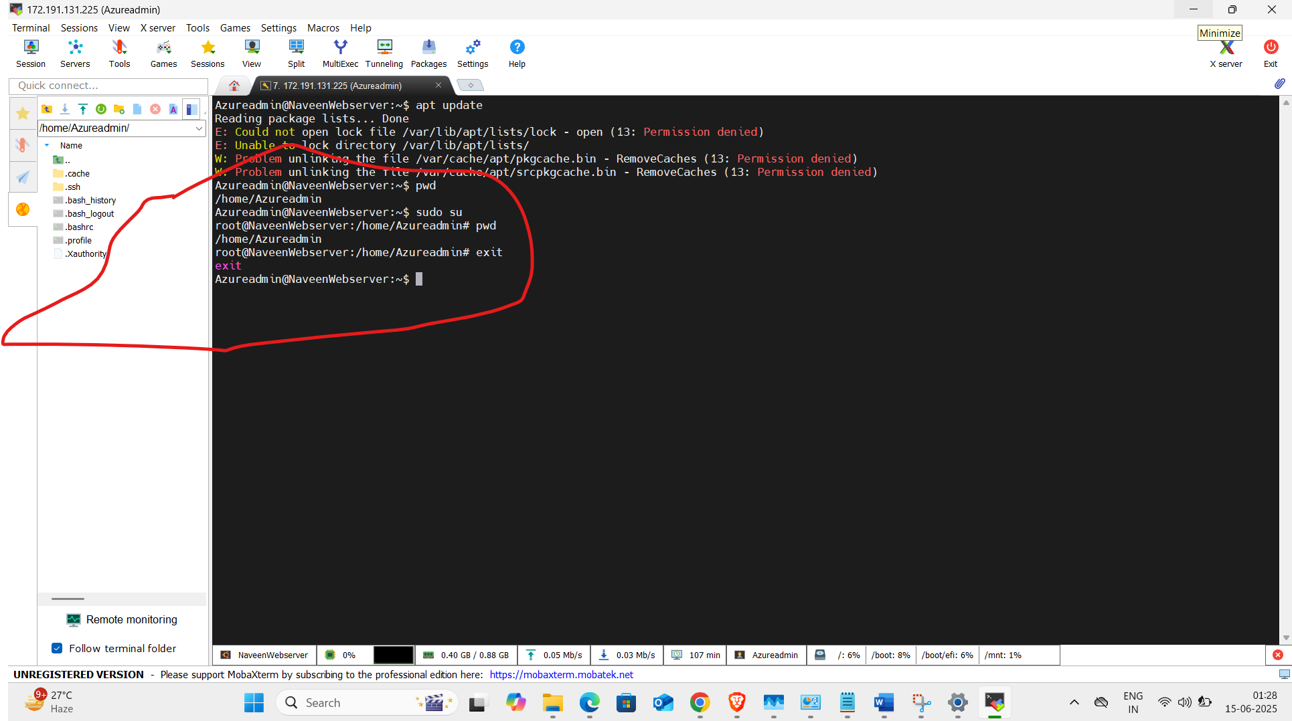

- When we enter sudo su -, we switch to the root user, and we are placed in the root user's home directory
- 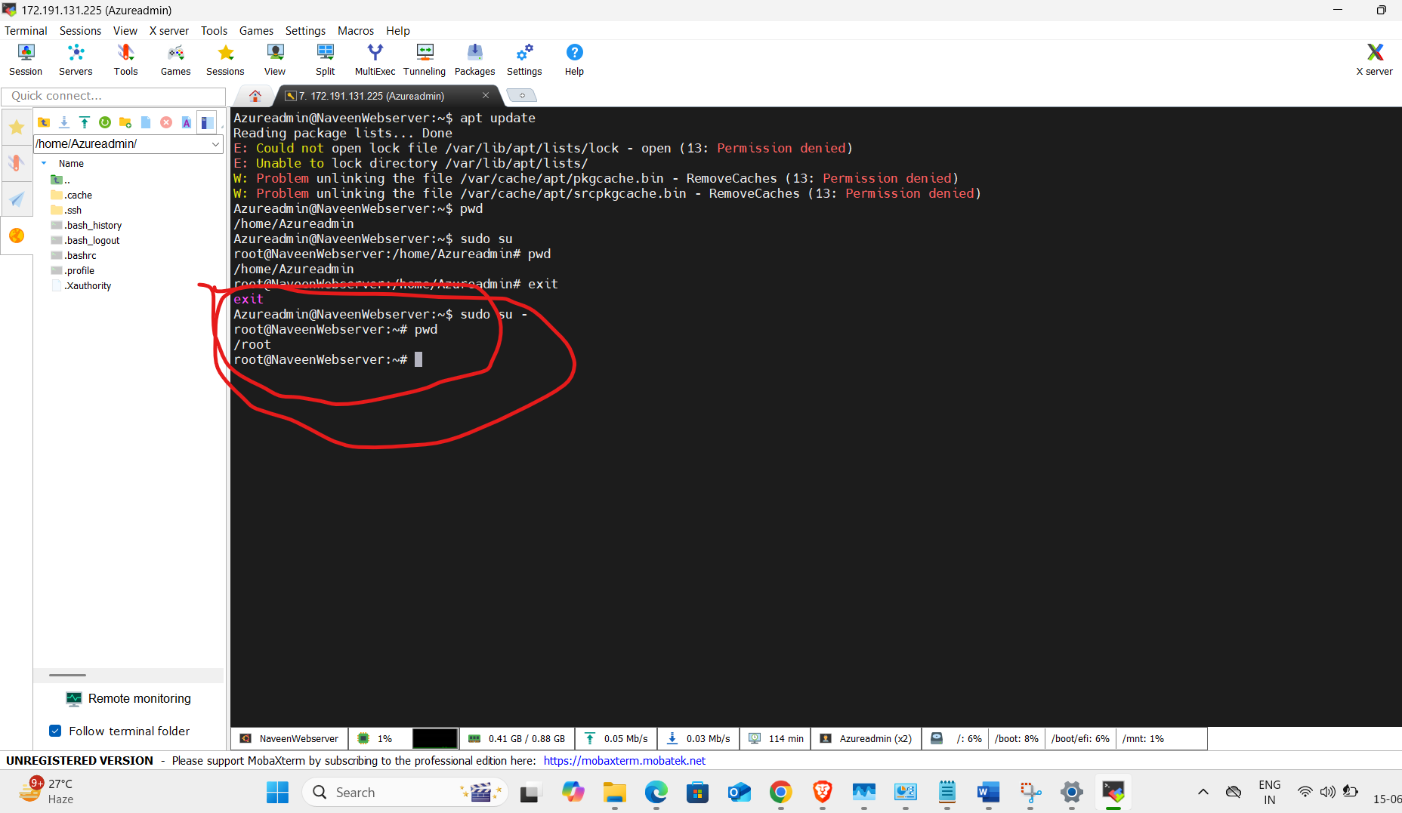
- After that update the app, we use cmd is “Apt update”
- 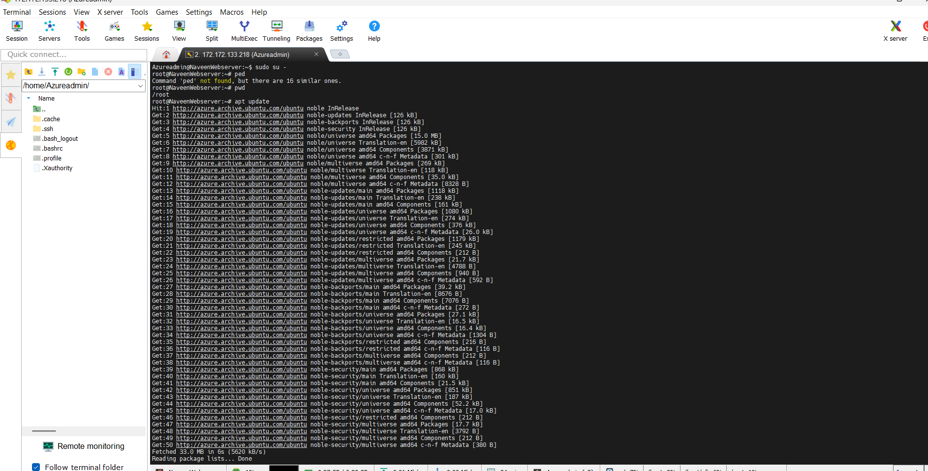
- App update is Done.
- After that we use cmd is “apt install nginx -y”

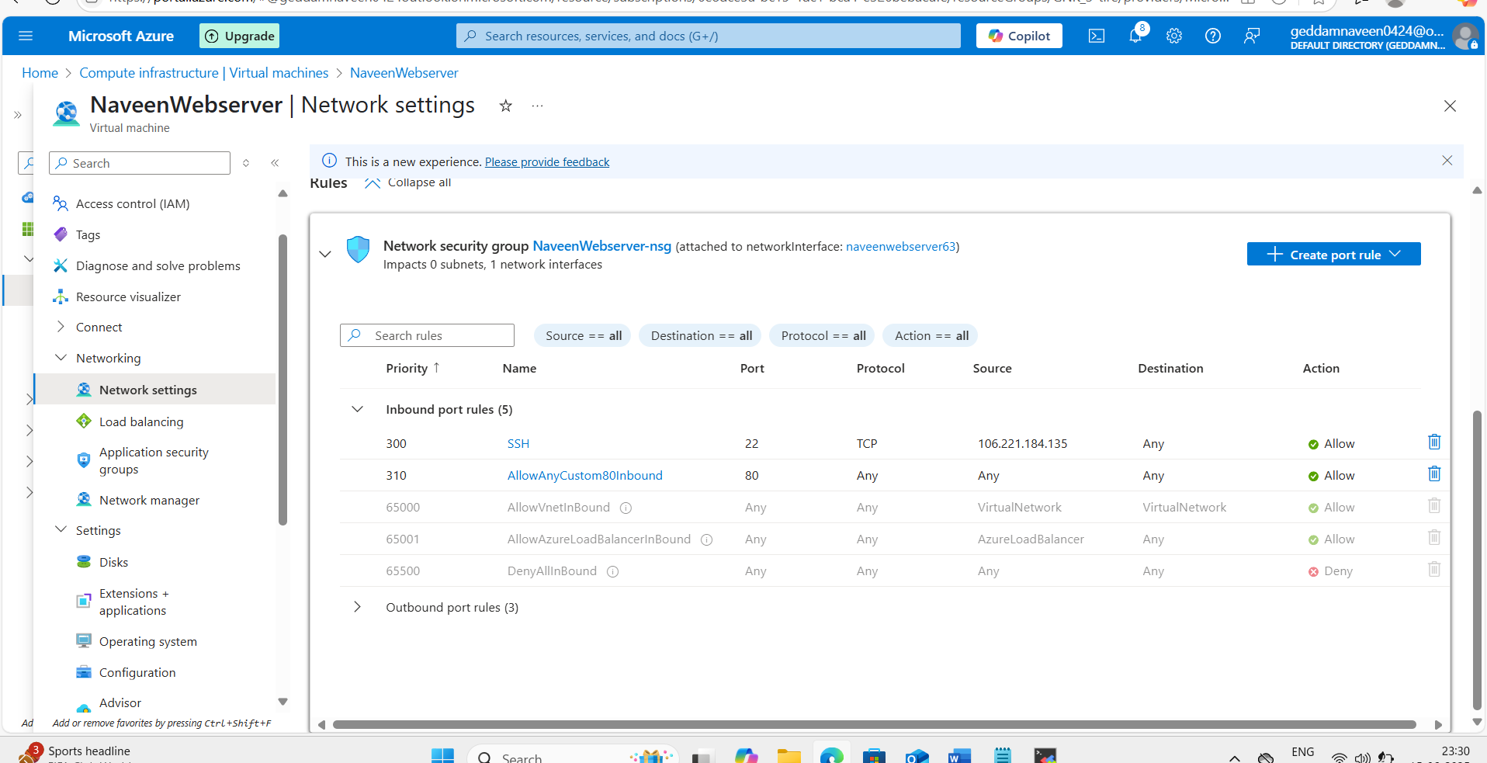

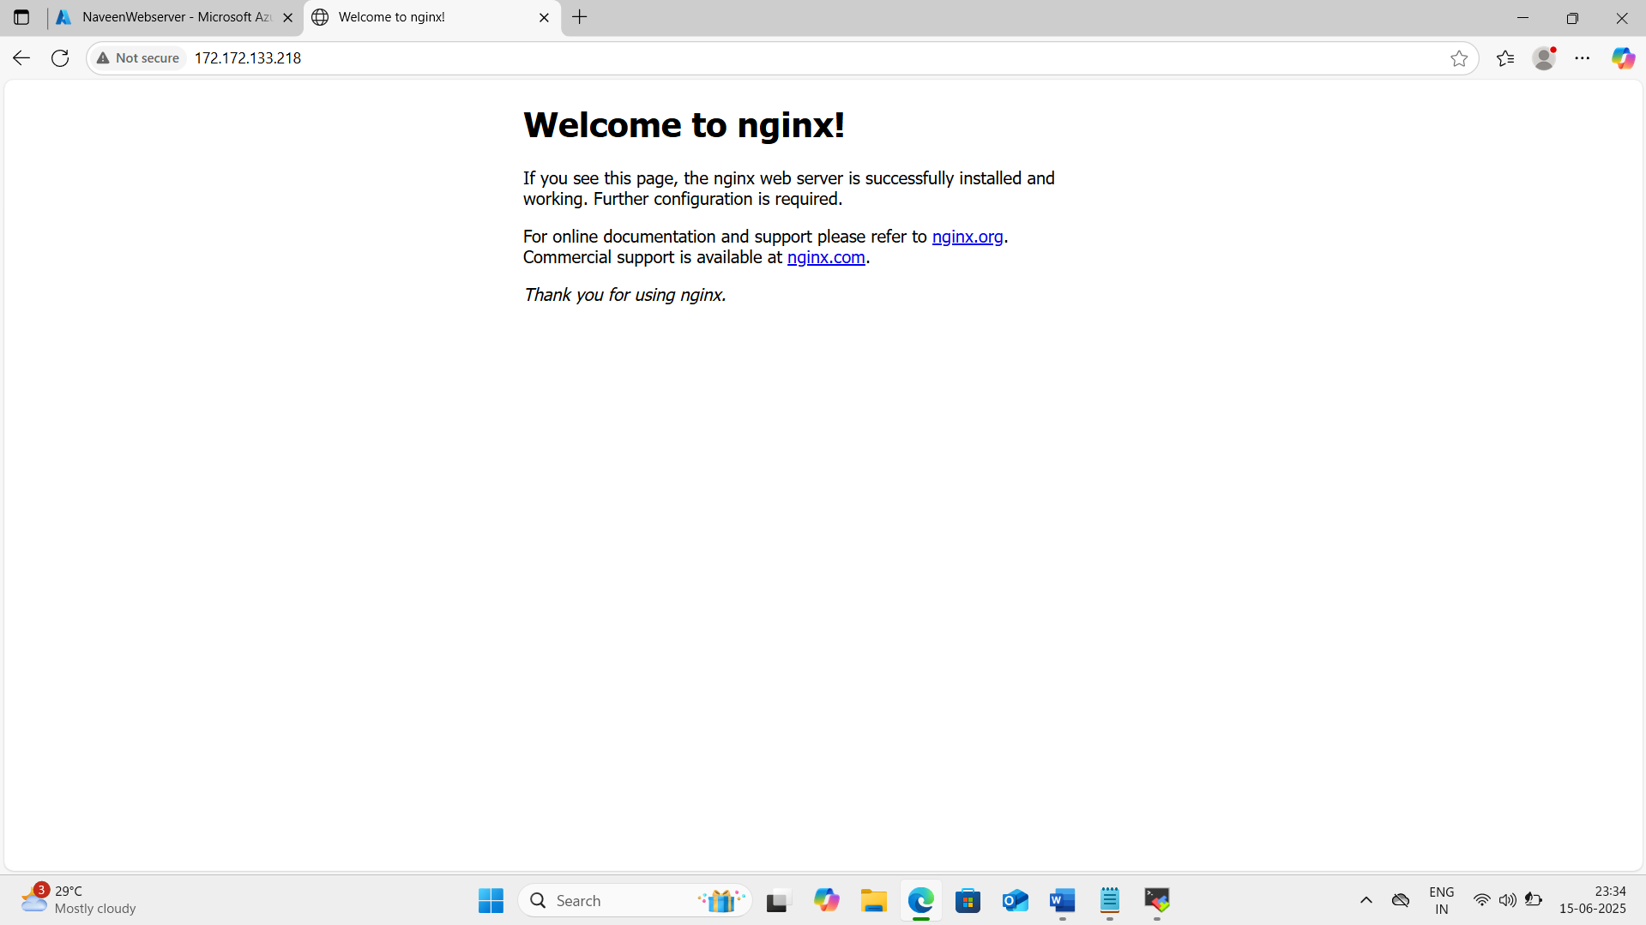

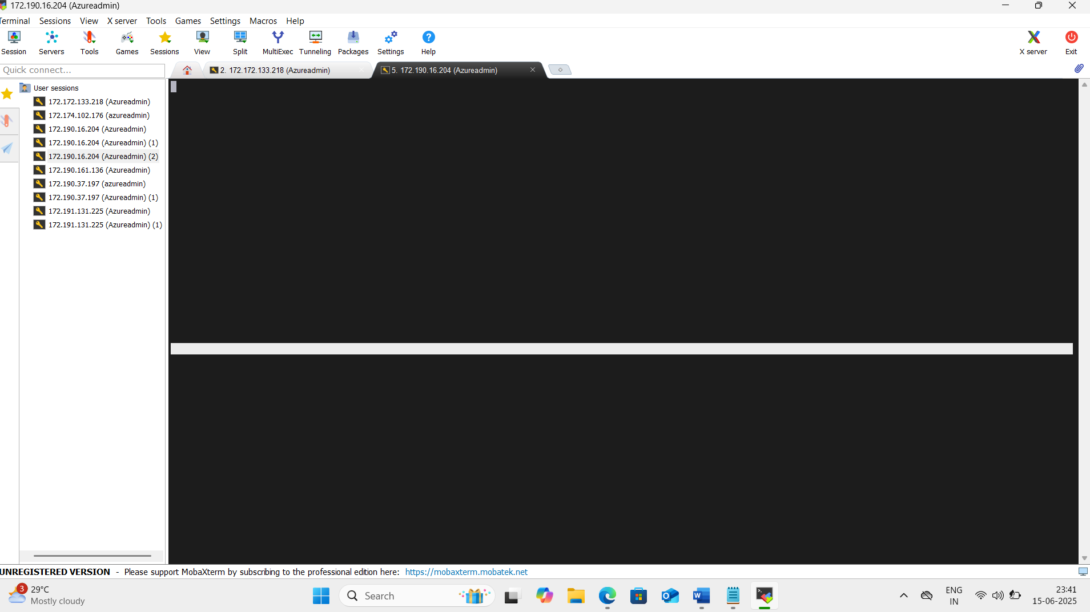
To install Apache Tomcat on Ubuntu, follow these steps:
To switch from a normal user ($ prompt) to the root user (# prompt) in Ubuntu, use any of the following
commands:
Method 1: Using sudo su (Recommended)
• sudo su
a. This switches you to the root user.
b. The prompt will change from $ to #.
Step 1: Update System Packages
• apt update
Step 2: Install Java
Tomcat requires Java. Install OpenJDK:
• apt install default-jdk -y
Verify the installation:
• java -version
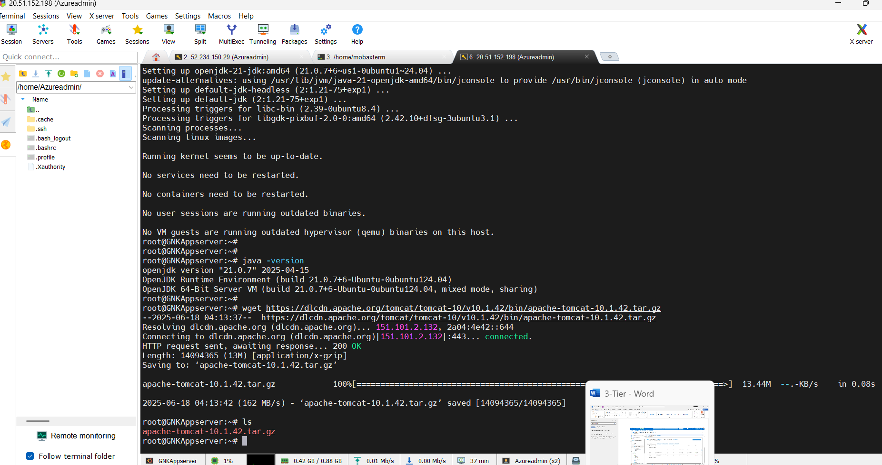
Step 3: Download Tomcat
• Go to the Apache Tomcat official website and get the latest version.
Run:
• wget https://dlcdn.apache.org/tomcat/tomcat-10/v10.1.18/bin/apache-tomcat-10.1.18.tar.gz
(Replace the version number with the latest one if needed.)
• ls (to list the files)
Step 4: Extract and Configure Tomcat
• tar -xvzf apache-tomcat-10.1.18.tar.gz
• ls
• mv apache-tomcat-10.1.18 tomcat
• ls
To start Apache Tomcat manually from the bin directory, follow these steps:
Step 1: Navigate to the Tomcat Directory
• cd /tomcat/bin
Step 2: Start Tomcat
Run the startup script: (./ is to execute a command)
• ./startup.sh
Step 4: Access Tomcat
Open your browser and go to:
http://your_server_ip:8080
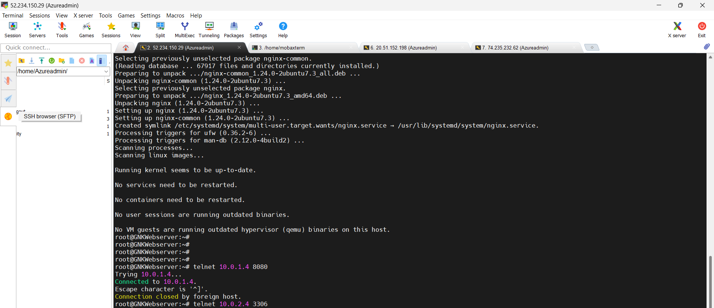
To install MYSQL on Ubuntu, follow these steps:
To switch from a normal user ($ prompt) to the root user (# prompt) in Ubuntu, use any of the following
commands:
Method 1: Using sudo su (Recommended)
• sudo su
c. This switches you to the root user.
d. The prompt will change from $ to #.
Step 1: Update System Packages
• apt update
➢ Run the following command to install MySQL:
• apt install mysql-server –y
➢ To improve security, run the following command:
• mysql_secure_installation
➢ Edit the MySQL configuration file using a text editor:
• nano /etc/mysql/mysql.conf.d/mysqld.cnf
➢ Locate the following line: bind-address = 127.0.0.1
• bind-address = 0.0.0.0
➢ EX: Modify it based on your requirement:
Scenario
Listen on all interfaces (for remote access)
Configuration
bind-address = 0.0.0.0
Listen on a specific IP (e.g., 192.168.1.100) bind-address = 192.168.1.100
• Save and exit (CTRL + X, then Y, then Enter).
➢ Apply the changes by restarting MySQL:
• systemctl restart mysql
➢ Check if MySQL is running:
• systemctl status mysql
